**Group name:** The Shifters

**Group members:** Tshegofatso Molobe, Brooke Franklin, Litha Stuurman and Tapiwa Pawandiwa.

**Group mentor:** Kristen Theunissen

**Project Title:** The Shifters Café Takeaway and Rhodes Campus Delivery System

**Project Description:** This program is designed to be used at a restaurant that has takeaway and delivery services. The delivery service for this program currently works for the Rhodes University Campus.

**Instructions for using the Application (allowable actions):**

There are two sides to the application: the managers side (not yet functional) and the tellers side.

The Teller Side:

Access is gained by supplying a matching user name (the teller ID) and password and navigated using Tab Control:

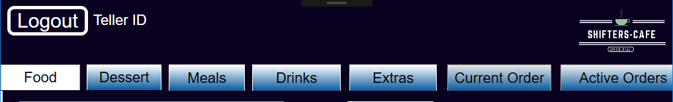  
*Fig 1. Tab Control*

The Menu is contained in a txt file which is automatically uploaded when the program is started.

Navigating The Menu

The menu is navigated using Tab Control. There are five tabs for Menu Items, namely: Meals, Extras, Desserts, Box Meals and Drinks (See Fig 1).

Adding Items to/Removing Items from an Order

Items are added by selecting an item from the list box and pressing the “Add Item” button available under each Menu Section Tab. The list of items ordered can be found under the Current Order Tab.

Pizzas and drinks come in three sizes: small, medium and large. When selecting either a Pizza or drink, a size must be selected as well using the tick box available on the respective tab. If a size in not selected, then the “medium size” will be selected as default.

Box Meals come with a choice of Coca-Cola drink. The teller must select a drink in order for the order to be added. Note, the size of the Coca-Cola drink is not optional in the case of Box-Items.

If a mistake Has been made in ordering the teller must go to the Current Order tab and remove the item that was incorrectly added. Manger approval will be needed and a Manager Login window will pop up in order to allow the item to be removed.

Completing an Order

An order can either be for takeaway or for delivery to students living on Rhodes University campus. The type of order can be chosen by selecting the appropriate check box next to the order window. If a checkbox is not selected the order cannot be completed.

A Takeaway Order:  
When completing a takeaway order, the teller must ensure that the customer has paid before the receipt can be printed. The receipt produced contains the café information, teller who put the order through, the details of the customer’s order, the cost of the order, amount paid and change received, as well as an order number (which is called when the order is ready to be collected).

The Shifters Café  
Grahamstown  
012 3456 789

Teller: ***

[Customer’s Order]

Total Cost: ###  
Total Paid: ###  
Change: ###

Order Number: ##

*Fig 2. Example of Takeaway Receipt*

The takeaway order will then be placed on a takeaway list under the active orders tab.

A Delivery to Rhodes Campus Order:  
When completing a delivery order, the teller must ensure that the customer details have been supplied (the customer name, contact number and residence) before the receipt can be printed. The receipt produced contains the café information, teller who put the order through, the customer details, the details of the customer’s order as well as an order number (which is called when the order is ready to be collected).

The Shifters Café  
Grahamstown  
012 3456 789

Teller: Name

Customer Name: ***  
Contact Number: ###  
Residence: ***

[Customer’s Order]

Total Cost: ###

Order Number: #

*Fig 3. Example of Delivery Receipt*

The delivery order will then be placed on a delivery list, depending on which campus the order is for, under the active orders tab. The order number is still completed so that the drivers know which orders they are responsible for.

Active Orders:

The Active Orders Tab displays the orders that have been put through for takeaway and delivery to the three campuses.

**Tools or Concepts Used:**

1. Files
2. Classes and objects
3. Overriding
4. Inheritance
5. Timer
6. Exceptions
7. Data Validation and Verification

**Our Assumptions:** [INSERT HERE]

**Our Limitations:** TIME